

ITA0324-Mobile Computing

Name: A. Anusha Reg no:19247083

Slot: C Course Name: Mobile Computing

Experiment 9: GSM Service User Interface Prototype
Aim: To develop a user interface prototype for a GSM service using Figma.
Procedure:
- Open Figma and create a new design file.
- Select a smartphone frame for the GSM application.
- Design a home screen showing the SIM and network status.
- Add voice call, SMS, and contact management options.
- Include signal strength and network registration indicators.
- Apply suitable colors, icons, and fonts to improve usability.
- Connect the screens using Prototype mode and test the navigation.

Output:
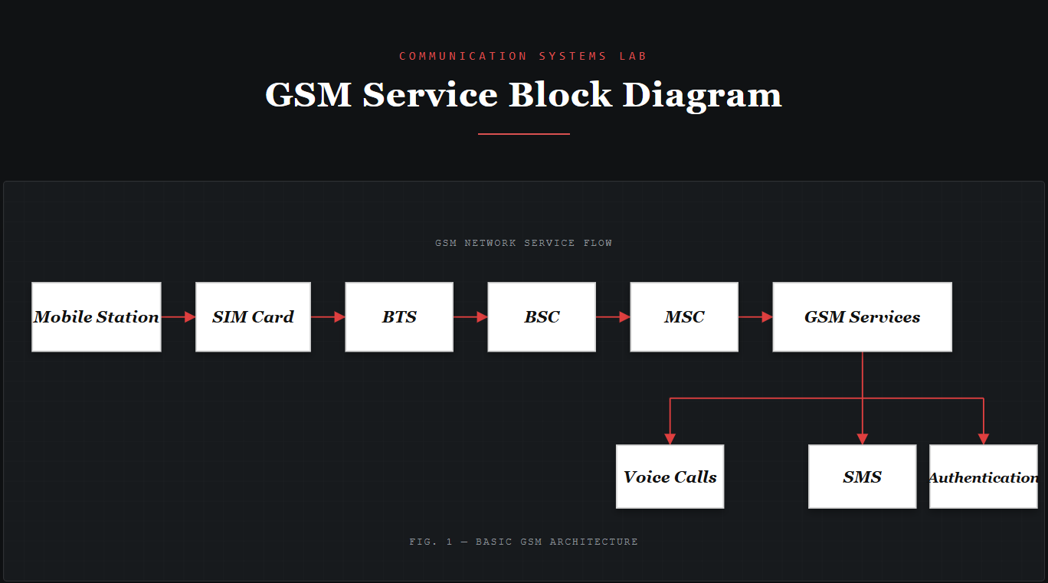
Result: Thus, a GSM service user interface prototype was developed successfully using Figma.

